Results Research Design

Findings and Results
The interview and observation data were analysed using thematic analysis. Participant responses were reviewed to identify repeated ideas, which were then coded and grouped into final themes. Participants were divided into two groups to reduce order bias, meaning that some participants tested the static dashboard first while others tested the animated version first. During the tasks, observations focused on how easily participants located financial information, interpreted charts, and interacted with dashboard features. The main themes identified were ease of navigation, clarity, engagement, distraction, and preference. Figure X displays a table of how selected participant comments were coded into themes.
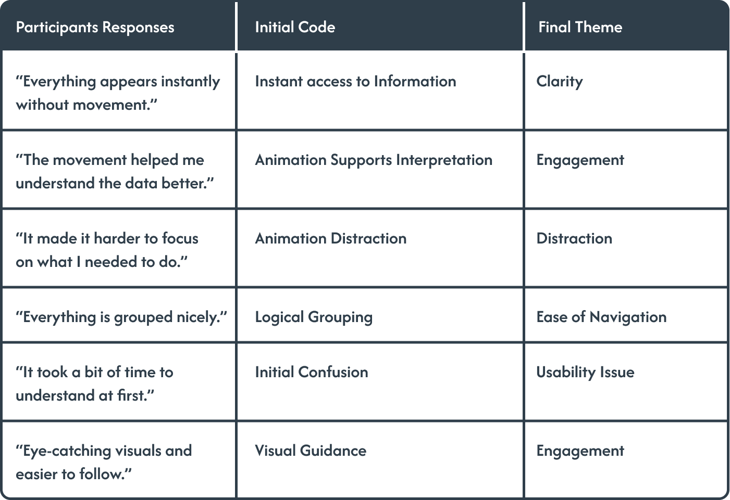
Figure 1: Thematic Coding Process

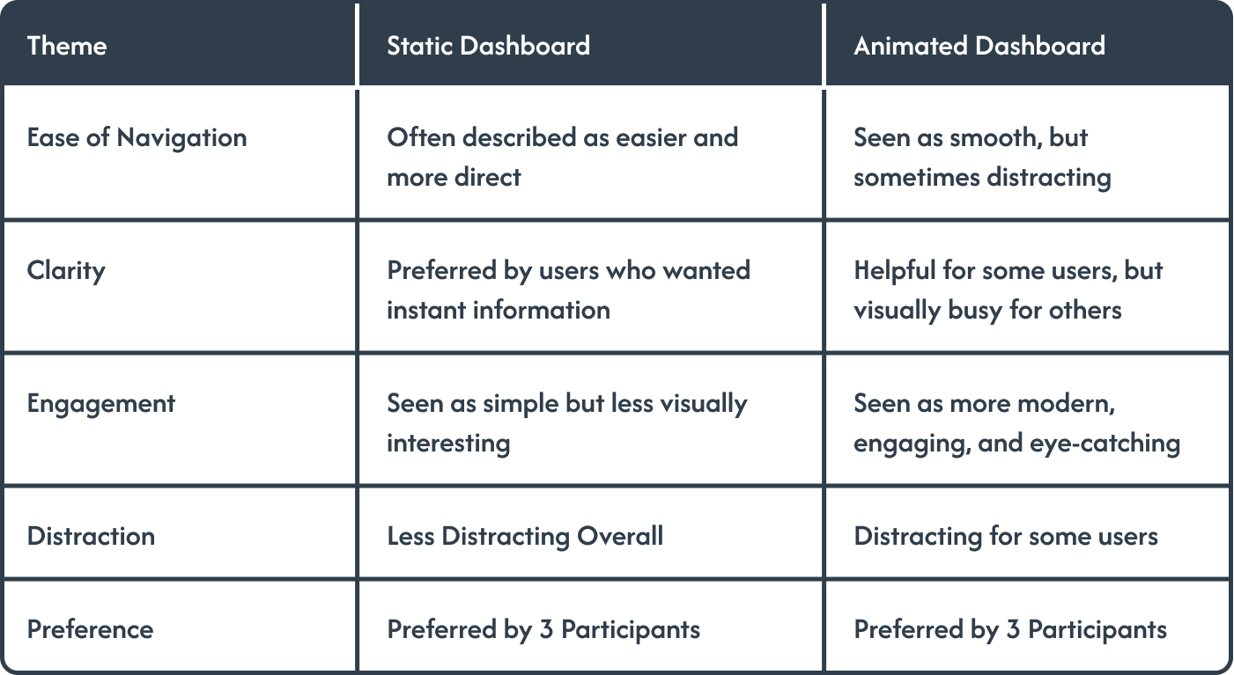
The coding process shows that participants’ comments were grouped according to recurring meanings rather than individual answers. For example, comments about information appearing instantly were coded under clarity, while comments about movement helping interpretation were coded under engagement. This helped organise the qualitative data into themes that could be compared across the static and animated dashboard versions.
Figure 2: Theme Comparison

The results in Figure X show that the static dashboard was mainly associated with clarity, direct navigation, and reduced distraction. Participants who preferred the static version explained that it allowed them to focus on the information without additional movement. In contrast, the animated dashboard was associated with engagement, visual appeal, and attention guidance, although some participants felt that the animation made the interface feel busier.

Overall, the findings partially support the hypothesis. The animated dashboard was perceived as more engaging and visually interesting, but it was not always considered easier to use. The static dashboard was preferred by participants who valued simplicity and fast access to information, while the animated version was preferred by participants who responded positively to visual feedback and movement.
Due to the small qualitative sample, the findings are not statistically generalisable. However, they provide useful transferable insights for similar dashboard design contexts. The results suggest that animation should be used carefully and purposefully in dashboard interfaces, as it can improve engagement but may also reduce clarity if it becomes distracting.

Findings and Results
The interview and observation data were analysed using thematic analysis. Participant responses were reviewed to identify repeated ideas, which were then coded and grouped into final themes. The main themes identified were ease of navigation, clarity, engagement, distraction, and preference. Figure X shows how selected interview comments were transformed into initial codes and then grouped into final themes.
The coding process demonstrates how the qualitative data was organised according to recurring meanings rather than isolated individual responses. For example, comments about information appearing instantly were coded as instant access to information and grouped under the theme of clarity. Similarly, comments about movement helping participants understand the data were coded as animation supports interpretation and grouped under engagement. This process made it possible to compare how participants experienced the static and animated dashboard versions.
Figure X shows that the static dashboard was mainly associated with clarity, direct navigation, and reduced distraction. Participants who preferred the static version explained that it allowed them to focus on the financial information without additional movement. This suggests that the static dashboard supported users who valued quick access to information and a more straightforward interface.
In contrast, the animated dashboard was associated with engagement, visual appeal, and attention guidance. Some participants felt that the movement helped them follow the information more easily and made the dashboard feel more modern and interactive. However, not all participants responded positively to the animations. For some users, the movement made the interface feel busier and slightly harder to focus on.
Overall, the findings partially support the hypothesis. The animated dashboard was perceived as more engaging and visually interesting, but it was not consistently considered easier to use. The static dashboard was preferred by participants who valued simplicity, clarity, and fast access to information, while the animated dashboard was preferred by participants who responded positively to visual feedback and motion.
Due to the small qualitative sample, the findings are not statistically generalisable. However, they provide useful transferable insights for similar dashboard design contexts. The results suggest that animation should be used carefully and purposefully in dashboard interfaces, as it can improve engagement but may reduce clarity if it becomes distracting.

